Little Mister & Miss Pageant
4th of July – Paxton
Sponsored by:

Wednesday, July 3rd at 6 p.m.
Pells Park Pavilion
BOYS & GIRLS AGES 5-7
2019-2020 School Year – Must be in the PBL district
Dress up in your favorite red, white, & blue outfit!
Prizes
Winners of Little Mister & Miss: $25 in Chamber Bucks
1st & 2nd Runner-up: $10 in Chamber Bucks
COST: $15/Contestant
Full Name: _______________________________________________________________
Address: _________________________________________________________________
Phone & Email: __________________________________________________________
Parent/Guardian Name: _________________________________________________
Birthday: ________________________________________________________________
*We will only accept the first twenty children that are registered by the deadline!*
Please have entry form and payment returned to the chamber office by Monday, June 25. Mail: PO Box 75, Paxton, Illinois 60957 – Drop-off: 103 North Market St., Paxton on Mondays & Wednesdays 8:30am - noon
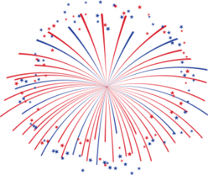
Questions? Call Laura Peverelle at (217) 417-5620

